HW #8 Q.1 Paper Summary
CBAM: Convolutional Block Attention Module (Woo, Park, Lee, Kweon, ECCV 2018)
Samih | EN525.733-8VL Deep Learning for Computer Vision
Motivation
CNN performance has historically been pushed by scaling depth, width, and cardinality. Woo et al. argue that another lever, attention, is underused inside the convolutional block itself. Their goal is to teach the network what to focus on (which channels carry meaningful detectors) and where to focus on (which spatial locations matter), in a way that is so cheap it can be inserted after every conv block without measurable cost.
Architecture
Given an intermediate feature map F of shape C x H x W, CBAM produces two attention maps in sequence: a 1D channel map M_c of shape C x 1 x 1, then a 2D spatial map M_s of shape 1 x H x W. Each map is broadcast and multiplied element-wise with the running feature map, so F′ = M_c(F) ⊗ F and F″ = M_s(F′) ⊗ F′. The order is intentional: the channel branch first decides which feature detectors are relevant, then the spatial branch refines where they fire.
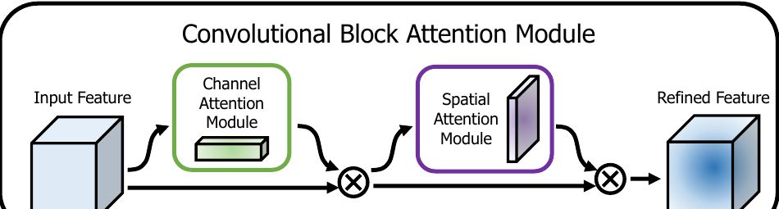
Figure 1. Overview of CBAM. Channel attention then spatial attention, applied at every convolutional block.
Channel attention module
To collapse the spatial dimensions into per-channel descriptors, the authors apply both average-pooling and max-pooling, producing F_avg^c and F_max^c. Both descriptors are pushed through the same shared MLP (a bottleneck with reduction ratio r = 16), and the two outputs are added and squashed by a sigmoid. The key departure from Squeeze-and-Excitation, which uses average-pooling alone, is the addition of max-pooling: average-pooling encodes soft global statistics, while max-pooling preserves the most salient response per channel, and the two are complementary at no extra parameter cost.
Spatial attention module
The spatial branch is symmetric. Average-pooling and max-pooling are applied along the channel axis, producing two H x W maps that are concatenated into a 2 x H x W descriptor. A single 7 x 7 convolution followed by a sigmoid yields the final spatial attention M_s. The ablation shows that pooling along the channel axis beats a learned 1 x 1 conv reduction, and that a 7 x 7 kernel beats 3 x 3, since deciding where to look needs a wide receptive field.
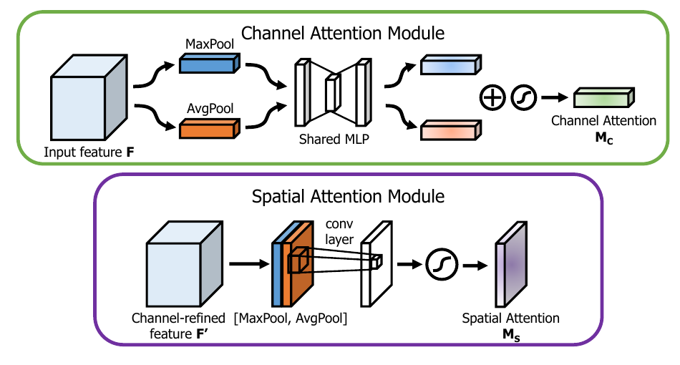
Figure 2. Channel and spatial sub-modules. Both rely on combined avg-pool and max-pool descriptors.
Integration with ResBlock
CBAM is dropped in after the convolution stack inside a residual block, so the refined feature is what gets added to the identity shortcut. The module is end-to-end trainable with the host network, and the parameter overhead is dominated by the small shared MLP in the channel branch.
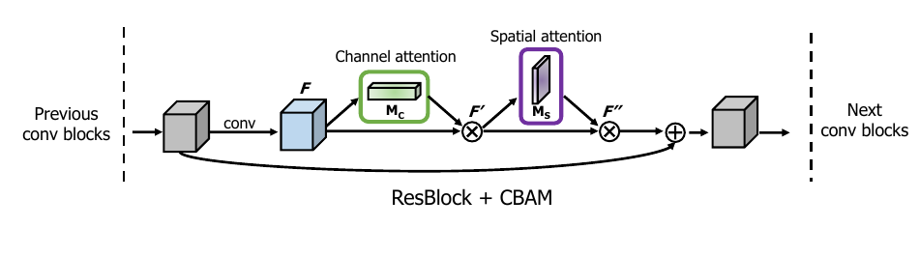
Figure 3. CBAM placed inside a ResNet residual block, before the skip-connection sum.
Key findings
Ablations. Combining avg-pool and max-pool in the channel branch beats either pool alone (top-1 error on ResNet-50 drops from 23.14% with SE-style avg-only to 22.80%). Sequential channel-then-spatial ordering beats both spatial-first and parallel arrangements. Channel-axis pooling with a 7 x 7 conv gives the best spatial map.
ImageNet-1K. CBAM consistently improves over SE across ResNet-18/34/50/101, WideResNet, ResNeXt, and MobileNet, with negligible parameter and FLOP overhead. The largest gain in the paper is ResNet-101 + CBAM at 21.51% top-1 error, versus 22.35% for SE and 23.38% for the baseline.
Detection. On MS COCO with Faster R-CNN, CBAM lifts mAP@[.5,.95] by roughly 1 point on both ResNet-50 and ResNet-101 backbones. On VOC 2007 with the StairNet detector, CBAM improves both VGG16 and MobileNet variants over their SE counterparts.
Qualitative. Grad-CAM visualisations show that CBAM-equipped networks concentrate on the actual object more tightly than the baseline or SE versions, and the softmax confidence on the ground-truth class rises accordingly. The authors interpret this as evidence that CBAM is suppressing irrelevant clutter rather than just adding capacity.
Takeaway
CBAM is a small, plug-and-play attention block that explicitly factors attention into a what (channel) and a where (spatial) computation, with the simple but effective trick of using both avg-pool and max-pool descriptors. It outperforms SE on classification and detection across many architectures and datasets, with parameter and compute overhead small enough that it is realistic even for mobile backbones.

